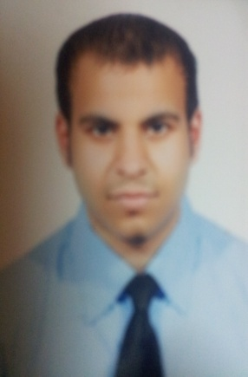**Name: Mohammed ahmed abass**

**Date of birth: 20-12-1990**

**Nationality: Bahraini**

**CPR Number: 901209317**

**Sex: male**

**Address: House520, Road 508, Block 1205**

**Hamad Town, Kingdom of Bahrain**

**Mobile: 39290291-33852865-37133369**

**Marital status: married**

***Education & Qualifications***

**Jun15,2009 _Dec 03,2009 Bahrain Institute of Hostility and Retail**

**Cross Selling and Cashiering –batch 26**

**2006_2009 Al_Jaberiya s. Tec .School Tec section**

***Employment history:***

**2010 to 2012 alraya suits hotel as driver and bellboy**

**2012 to 2013 Sphinx service as diver**

**2013 to 2014 fraser suits hotel as driver**

**2014 to 2016 uinted arab consrtion as driver**

***Additional Skills:***

* **Languages: Good commands of spoken and written Arabic and English.**
* **Computer skills: MS Word, MS Excel, MS Access and MS PowerPoint.**

***Other Interests:***

* **Internet Surfing, searching for information**
* **Watching English movies**

***References***

* **You can ask about me in sphinx service…….Mr ahmed in hr tell: 17700032**
* **You can ask about me in alraya suits hotel….Ms lena in hr tell:17555888**
* **You can ask about me in fraser suits hotel….Mr adnan in hr tell:17171626**
* **You can ask about me in united arab..Ms Fatima in hr tell:17255491**